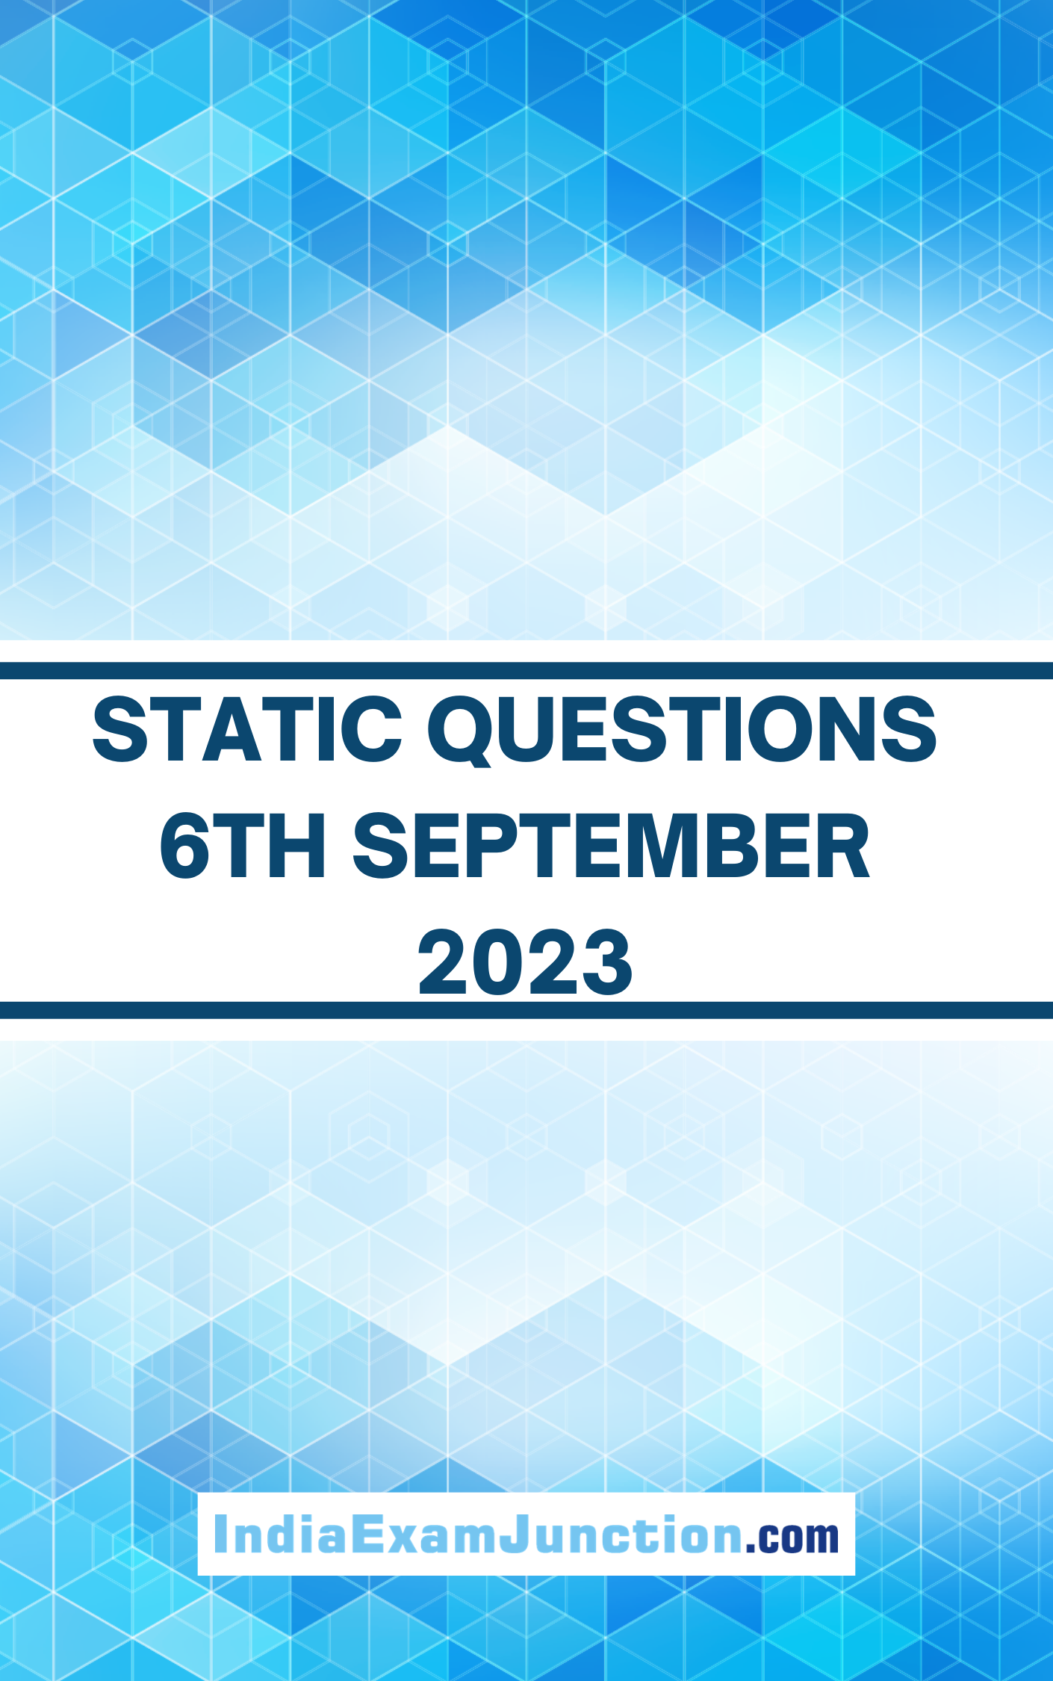

1. ‘A TRAIN TO PAKISTAN’ novel was written by

(a) Amir Singh (b) Milkha Singh (c) Khushwant Singh (d) Jaswant Singh

2. Which of the following articles makes provision for reservation of SC/ST in government services?

(a) Article 332 (b) Article 333 (c)Article 334 (d) Article 335

3. When was the states Reorganization Commission appointed by the Govt. of India?

(a)1974 (b) 1953 (c) 1954 (d) 1955

4. The standard of living in a country is represented by its:

(a) National income (b) Per capita Income

(c) Poverty Ratio (d) Unemployment rate

5. What Smallest number Should be added to 4456 so that the sum is completely divisible by 6?

(a) 4 (b) 3 (c) 2 (d) 1

6. The first known ruler to introduce canal irrigation in India was

(a) Krishnadevaraya (b) Firoz shah Tughlaq

(c) Akbar (d) Tipu Sultan

7. Changing an existing document is called:

(a) Creating (b) Editing (c) Modifying (d) Adjusting

8. Setting fonts for the text in your document is an example of:

(a) Formatting (b) Formulas (c) Tracking changes (d) Tools

9. Who among the following was the first Bhakti Saint to Use Hindi for the propagation of his message?

(a) Dadu (b) Kabir (c) Ramananda (d) Tulsidas

10. Constitutional Safeguards to Civil Servants are ensured by:

(a) Article 310 (b) Article 317 (c) Article 312 (d) Article 311

ANSWER KEYS

|  |  |  |  |  |  |  |  |  |  |
| --- | --- | --- | --- | --- | --- | --- | --- | --- | --- |
| **Q.No.** | **Ans** | **Q.No.** | **Ans** | **Q.No.** | **Ans** | **Q.No.** | **Ans** | **Q.No.** | **Ans** |
| 1. | C | 2. | D | 3. | B | 4. | B | 5. | C |
| 6. | B | 7. | B | 8. | A | 9. | C | 10. | D |